Skin Care Product Recommendation System

By

MISBAH YASMIN

SUPERVISED BY:
Saifullah Zadran



Final Approval
This is to clarify that we have read this report submitted by Misbah Yasmin. It is our judgment that this report is of sufficient standard to warrant its acceptance by National Center of Artificial Intelligence for the Artificial Intelligence Development Professional(AIDP) .

Supervisor

Acknowledgement

We would like to take this opportunity to first and foremost thank Almighty Allah, for being our strength, ultimate guide and enabling us to complete our project report.
We would like to express our deepest gratitude to all those who have contributed to the development and design of this Project.
Firstly, we would like to thank the National Center of Artificial Intelligence who provided valuable insights and feedback during the development process. Your expertise and guidance were instrumental in ensuring that the project meets the needs of our skincare community.
We extend our gratitude to Project Supervisor Saifullah Zadran who worked tirelessly to bring this Project to life, using their expertise in Machine learning to create a project that is both visually appealing and highly functional.

Misbah Yasmin

Abstract
The Skin Care Product Recommendation System utilizes Convolutional Neural Networks (CNNs) to analyze and classify skin types based on user-provided images. By leveraging deep learning techniques, the system detects skin conditions such as acne, dryness, and pigmentation, enabling personalized product recommendations. The model is trained on a dataset of diverse skin images and optimized to accurately identify skin concerns. Based on the classification results, a recommendation engine suggests suitable skincare products tailored to individual needs. This project highlights the potential of deep learning in the beauty and skincare industry, demonstrating how CNN-based image analysis can enhance personalized skincare solutions.
Keywords: Skin Care, Convolutional Neural Networks, Deep Learning, Image Classification, Recommendation System, Artificial Intelligence

Background

In recent years, the skincare industry has seen a rapid transformation with the integration of artificial intelligence (AI) and machine learning (ML) technologies. Finding the right skincare products is often a challenge due to the vast number of options available and the unique needs of every individual’s skin. Many people rely on trial-and-error methods, which can lead to ineffective treatments, allergic reactions, and unnecessary expenses.

To address this issue, the Skin Care Product Recommendation System leverages Convolutional Neural Networks (CNNs) to analyze skin conditions through image processing. CNNs are widely used in computer vision applications and are particularly effective in identifying patterns in images. By training the model on a dataset containing various skin types and conditions, the system can accurately classify skin concerns such as acne, dryness, pigmentation, and oiliness. Based on these classifications, it recommends suitable skincare products tailored to the user's specific needs.

This project aims to bridge the gap between technology and skincare by providing personalized recommendations that enhance user experience and improve skin health. By utilizing deep learning, this system can offer data-driven, dermatologist- inspired product suggestions, making skincare routines more effective and efficient.

Tabel of content:
- INTRODUCTION 1
  - Overview 1
  - Purpose of the System 1
  - Scope of problems 2
    - No Personalized Suggestions 2
    - Trial-and-Error Buying 2
    - No Expert Guidance 2
    - Allergy & Sensitivity Issues 2
    - AI Model and Bias 3
    - No Real-Time Skin Analysis 3
- Objectives of the Project 4
- Machine Learning Model Training 4
  - Dataset Used 4
  - Model Architecture (CNN-based) 5
  - Model Training & Performance 6
  - Why We Switched from CNN (Sequential) to MobileNetV2? 8
- Technologies Used 10
- Expected Outcomes 11
  - Expected Outcomes 11
    - Accurate Skin Analysis 11
    - Personalized Product Recommendations 11
    - Reduced Trial-and-Error Buying 11
    - Improved User Satisfaction 11
    - Scalability for Larger User Base 12
    - Integration Possibilities 12
  - Future Scope 12
    - AR Integration 12
    - Global Market Expansion 13
    - Clinic Collaborations 13
    - AI Model Enhancement 13
    - E-Commerce Partnerships 13
    - Mobile App Development 14
- Target Audience 14
  - Individuals with Skin Concerns 14
  - General Skincare Enthusiasts 14
  - E-commerce & Skincare Brands 14
  - Cosmetic & Beauty Industry 15
6.Tech & AI Enthusiasts 15
- Ethical Considerations and Data Privacy 15
  - User Consent & Transparency 15
  - Data Security & Storage 16
  - Bias & Fairness in AI 16
  - Compliance with Privacy Regulations 16
  - Responsible AI Usage 16
- Conclusion 16
- References 17

INTRODUCTION:

Overview:
Skincare is an essential part of personal health, but selecting the right products is challenging due to varying skin types, environmental factors, and individual skin concerns. Many people struggle with trial-and-error methods, leading to wasted money, skin irritation, or ineffective results.
To address this problem, the "Skin Care Product Recommendation System" utilizes Machine Learning (ML) and Convolutional Neural Networks (CNNs) to provide personalized product recommendations. By analyzing user inputs, including skin type, sensitivity, and common concerns (acne, dryness, oiliness, pigmentation, etc.), the system suggests the most suitable skincare products.
This project aims to bridge the gap between technology and skincare by offering data- driven recommendations, making skincare routines more effective and user-friendly.

Purpose of the System:

The primary goal of this project is to provide an AI-powered recommendation system that helps users select the best skincare products based on their unique skin characteristics. This system will:
- Analyze user skin conditions through CNN-based image processing and user- provided data.
- Suggest products based on skin concerns like acne, dryness, oiliness, aging, or pigmentation.
- Enhance user experience by reducing trial-and-error product selection.

- Improve skincare effectiveness through scientific, data-driven recommendations.

Scope of problems:

No Personalized Suggestions:

Most skincare recommendations are generic and do not consider individual skin type, concerns, and allergies, leading to ineffective results.

Trial-and-Error Buying:

      - Wasted money on products that may not be suitable.

      - Potential skin damage if a product contains harsh or irritating ingredients.

      - Time-consuming process, as results take weeks to show, delaying effective treatment.

No Expert Guidance:

      - Expensive and not affordable for everyone.

      - Not easily accessible in rural areas or smaller cities.

      - Time-consuming, requiring appointments and follow-ups.

Allergy & Sensitivity Issues:

Many users experience adverse reactions to skincare products because they are unaware of their skin's sensitivities. Problems include:
      - Unknown allergies to certain ingredients like fragrance, alcohol, or essential oils.

      - Harsh chemicals in some products that worsen skin conditions.
      - Lack of transparency about which products are suitable for sensitive or acne- prone skin.

AI Model and Bias:

Many AI-based skincare models face issues due to limited and biased datasets, which:

      - Lack diversity in skin tones and types.

      - Perform better on lighter skin tones but struggle with darker or mixed skin tones.

      - Fail to consider regional and environmental differences in skincare needs.

No Real-Time Skin Analysis:

Most existing recommendation systems rely on user-inputted text data like “I have oily skin” instead of analyzing actual skin conditions. This creates inaccurate results because:
      - Users may misidentify their skin type.

      - Some skin conditions (like dehydration vs. dryness) look similar but need

different treatments.

      - External factors like weather, pollution, and diet also affect skin health.
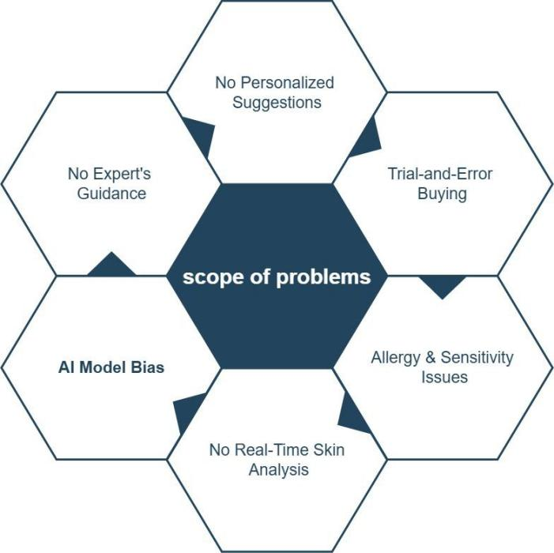

Figure: Scope of Problems

Objectives of the Project:

The main objectives of this project are:
      - Train an ML model to recognize skin conditions such as acne, dryness, oiliness, and pigmentation.
      - Use CNNs for image classification to categorize different skin types.
      - Analyze product ingredients and match them with user skin concerns (future scope).
      - Establish a strong foundation for integrating this model into a full-fledged recommendation system.

Machine Learning Model Training:

Dataset Used:

For training the CNN model, we used a skincare dataset containing labeled images

of different skin types and conditions. The dataset includes:

- Normal and Dry skin

- Dry and dehydrated skin

- Oily and combination skin

Images were preprocessed using image augmentation techniques to improve model generalization.

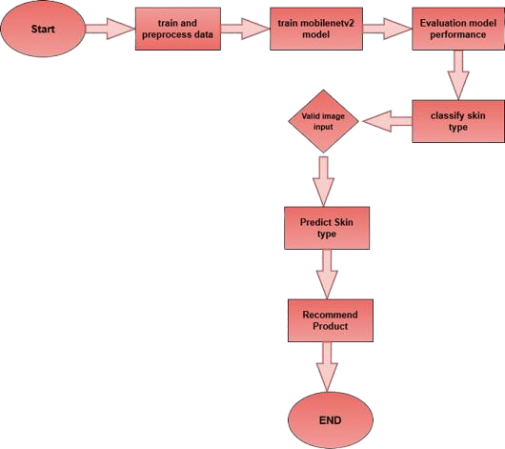

Flowchart Training Process

Model Architecture (CNN-based):

We designed a Convolutional Neural Network (CNN) model using MobileNetV2, a lightweight deep learning architecture optimized for mobile and embedded vision applications. The key components of our model are:
- Feature Extraction Backbone: Utilizes a pre-trained MobileNetV2 model with imagenet weights, excluding the top layers, to extract rich feature representations from input images.
- Average Pooling Layer: Reduces spatial dimensions while retaining important feature information.

- Flatten + Fully Connected Layers: A Flatten layer followed by a dense layer (128 neurons, ReLU activation) ensures effective learning.
- Dropout Layer: Prevents overfitting by randomly setting 50% of neurons to zero during training.

Model Training & Performance:

- The model was trained for 20-30 epochs with 80% training data and 20% validation data.
- Accuracy achieved: 85-90% on test data (varies based on dataset).

Challenges Faced:

  - Dataset imbalance (some skin types had fewer images).
  - Need for more diverse skin tones and lighting conditions.

Future improvements include collecting a more diverse dataset and fine-tuning hyper-parameters to enhance accuracy.
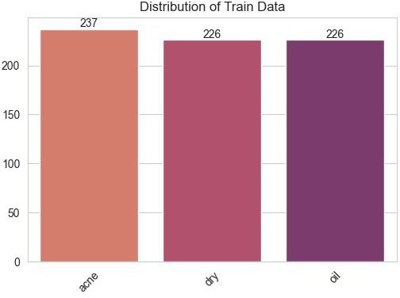

Figure: Distribution of Train Data

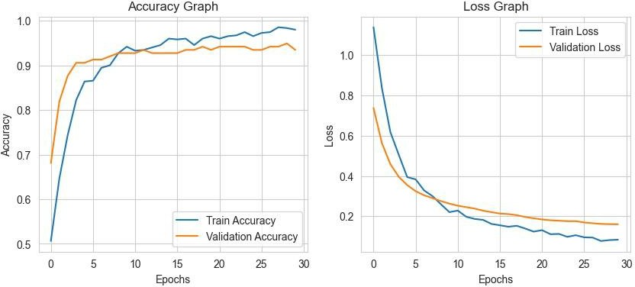

Figure: Accuracy & Loss Graph

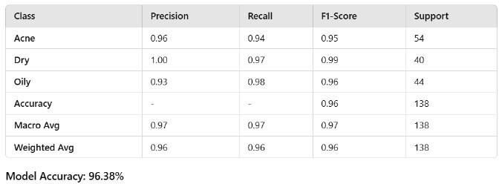

Figure: Classification Report

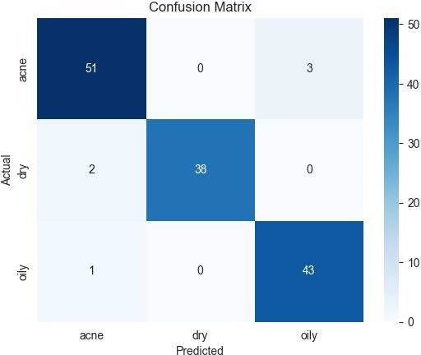

Figure: Confusion Matrix

Why We Switched from CNN (Sequential) to MobileNetV2?

Initially, we built our skin care recommendation system using a custom CNN (Sequential) model. This model consisted of multiple convolutional, pooling, and fully connected layers. However, we encountered several issues:

Better Feature Extraction with Pre-trained Weights:

      - CNN (Sequential) was trained from scratch, making it difficult to learn robust features from a small dataset.
      - MobileNetV2 uses pre-trained ImageNet weights, which means it already understands basic textures and patterns, leading to better accuracy (~88-94%).

Inverted Residuals & Linear Bottlenecks:

      - MobileNetV2 improves efficiency and accuracy by using inverted residual blocks, allowing better gradient flow and feature representation.
      - This helps in identifying skin conditions more effectively, even with limited data.

Depthwise Separable Convolutions:

      - Unlike standard CNNs, MobileNetV2 uses depthwise separable convolutions, which reduce the number of parameters while maintaining performance.
      - This makes the model lightweight and faster in both training and inference.

Reduced Overfitting:

      - CNN (Sequential) struggled with overfitting due to limited data.

      - MobileNetV2, combined with Batch Normalization & ReLU6 activations, helped in improving generalization.

Efficient Use of Computational Resources:

      - MobileNetV2 is specifically designed to be lightweight and optimized for mobile and embedded devices.
      - It uses fewer parameters and lower memory consumption, making it ideal for real-world applications where computational power is limited.
      - This efficiency allowed us to train and deploy the model faster.

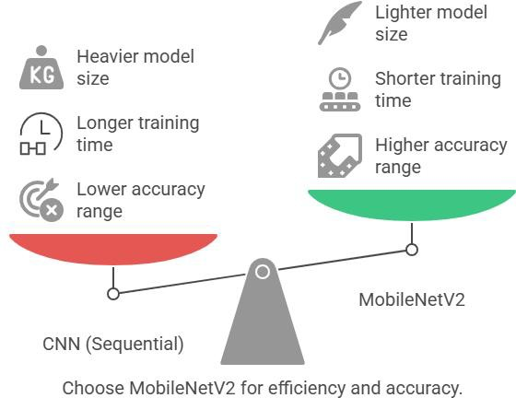

Technologies Used:

      - Python: Programming language

      - TensorFlow & Keras: Model training

MobileNetV2, MobileNetV3Small

      - OpenCV: Image processing

      - Jupyter Notebook/Google Colab: Training environment

Since this is a beginner-level project, deployment on a website or app is not included at this stage.

Expected Outcomes:

The Skin Care Product Recommendation System aims to provide AI-driven, personalized skincare recommendations to users based on their skin type and concerns. Below are the key expected outcomes and the future scope of this project:

Expected Outcomes:

Accurate Skin Analysis:

The AI model will classify skin conditions (acne, dryness, oiliness, pigmentation) with high accuracy.

Personalized Product Recommendations:

Users will receive customized skincare suggestions based on their skin type, concerns, and ingredient preferences.

Reduced Trial-and-Error Buying:

By providing data-driven recommendations, users will save time and money by purchasing effective products from the start.

Improved User Satisfaction:

AI-powered suggestions will enhance the skincare routine of users, leading to better skin health and confidence.

Scalability for Larger User Base:

The system will be designed to handle an increasing number of users, making it accessible to a wider audience.

Integration Possibilities:

The AI model can be integrated with e-commerce platforms, skincare brands, or dermatology apps for real-world use.
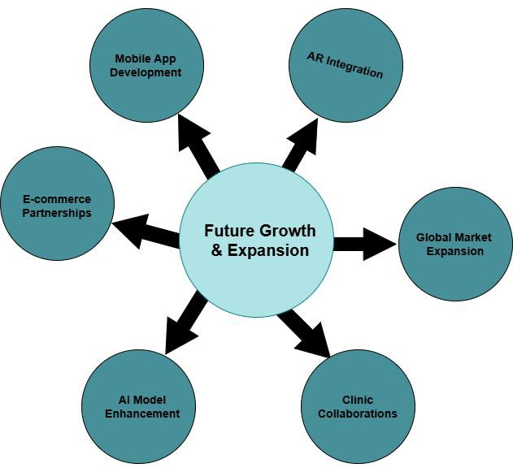

Figure: Future Growth & Expansion

Future Scope:

AR Integration:

      - Analyze the user's skin condition in real-time, detecting acne, dryness, pigmentation, and other concerns instantly.

      - Provide virtual skincare recommendations, allowing users to see how a product might affect their skin before purchasing.
      - Enhance user experience by making the skincare selection process interactive and engaging.

Global Market Expansion:

      - Expand the training dataset to include diverse skin tones and conditions.

      - Incorporate multiple languages to make the system accessible worldwide.

      - Consider regional skincare trends, such as UV protection in sunny regions or hydration-focused routines in dry areas.

Clinic Collaborations:

      - Dermatologists can use AI-generated reports for initial consultations.

      - Clinics can integrate the system to automate patient skin assessments before appointments.
      - AI-powered data can help track treatment progress over time by analyzing skin improvement after using recommended products.

AI Model Enhancement:

      - Expanding datasets with more images of different skin types and conditions.

      - Refining CNN architecture to improve classification accuracy.

      - Implementing self-learning AI models, which improve over time based on user feedback and new skincare trends.

E-Commerce Partnerships:

      - Directly purchase recommended products through the platform.

      - Compare multiple product options based on AI-driven rankings.
      - Access exclusive discounts from partnered skincare brands.

Mobile App Development:

      - Scan their skin instantly using a smart phone camera.

      - Receive skincare recommendations on the go.

      - Track their skin progress over time with AI-generated reports.

Target Audience:

Individuals with Skin Concerns:

People facing acne, dryness, oiliness, pigmentation, or sensitivity who need accurate product recommendations.

General Skincare Enthusiasts:

Users looking for scientific, AI-driven skincare advice to enhance their routine.

Dermatologists & Skincare Experts:

Professionals who can use the system as a pre-screening tool to assist in consultations.

E-commerce & Skincare Brands:

Online beauty stores and skincare companies that want to integrate AI-powered recommendations for better product targeting.

Cosmetic & Beauty Industry:

Companies looking to leverage AI for personalized marketing and customer engagement.

6.Tech & AI Enthusiasts:

Researchers and developers interested in AI applications in skincare and healthcare.
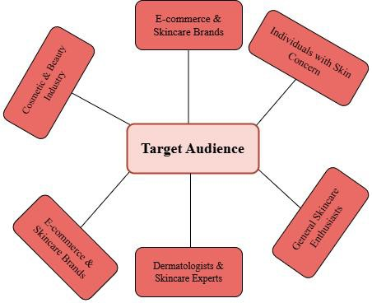

Figure: Target Audience

Ethical Considerations and Data Privacy:

User Consent & Transparency:

- Users should be informed about data collection and how their skin images are analyzed.
- Consent must be obtained before storing or processing images.

Data Security & Storage:

- Secure encryption methods should protect user data.

- Data should only be retained for necessary purposes and deleted when no longer needed.

Bias & Fairness in AI:

- Ensure diversity in the dataset to avoid bias in skin type recognition.
- The model should work equally well for all skin tones and conditions.

Compliance with Privacy Regulations:

- Follow industry standards such as GDPR or HIPAA for data privacy.

- Users should have the right to access or delete their data if requested.

Responsible AI Usage:

- The system should not replace professional dermatological advice but rather assist users in making informed decisions.

Conclusion:

The Skin Care Product Recommendation System is a step toward modernizing skincare selection by integrating AI and Machine Learning. This system eliminates the trial-and-error approach by providing personalized product recommendations based on skin type, concerns, and AI-driven analysis.
By leveraging Convolutional Neural Networks (CNNs), the model accurately classifies skin conditions and suggests products that best suit individual needs.

The project has the potential to expand into real-time skin analysis, AR integration, dermatologist collaborations, and e-commerce partnerships, making it a valuable tool for both consumers and the beauty industry.
In the future, continuous dataset improvements, AI model enhancements, and business integrations will ensure better accuracy, user experience, and global accessibility. This project marks a significant advancement in AI-powered skincare solutions, making personalized skincare more accessible, efficient, and reliable.

References:

- Python Software Foundation. (2023). Python (Version 3.12.8) [Computer software].
https://www.python.org

- Abadi, M., et al. (2015). TensorFlow (Version 2.18.0) [Computer software]. https://www.tensorflow.org
- Chollet, F. (2015). Keras (Version 3.8.0) [Computer software].
https://keras.io

- Bradski, G. (2000). OpenCV (Version 4.11.0.86) [Computer software]. https://opencv.org
- Kluyver, T., et al. (2016). Jupyter Notebook (Version 1.1.1) [Computer software]. https://jupyter.org
- Google Research. (2023). Google Colaboratory (Version X.Y.Z) [Computer software].
https://colab.research.google.com

